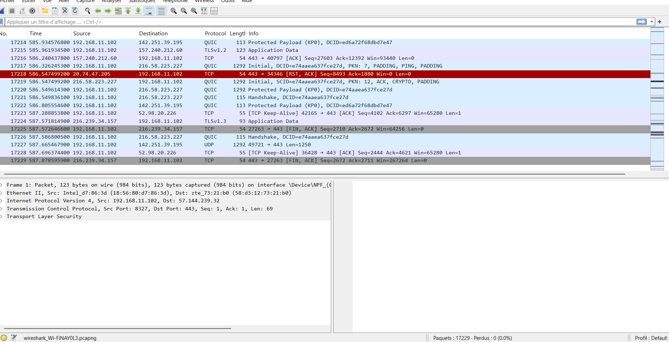

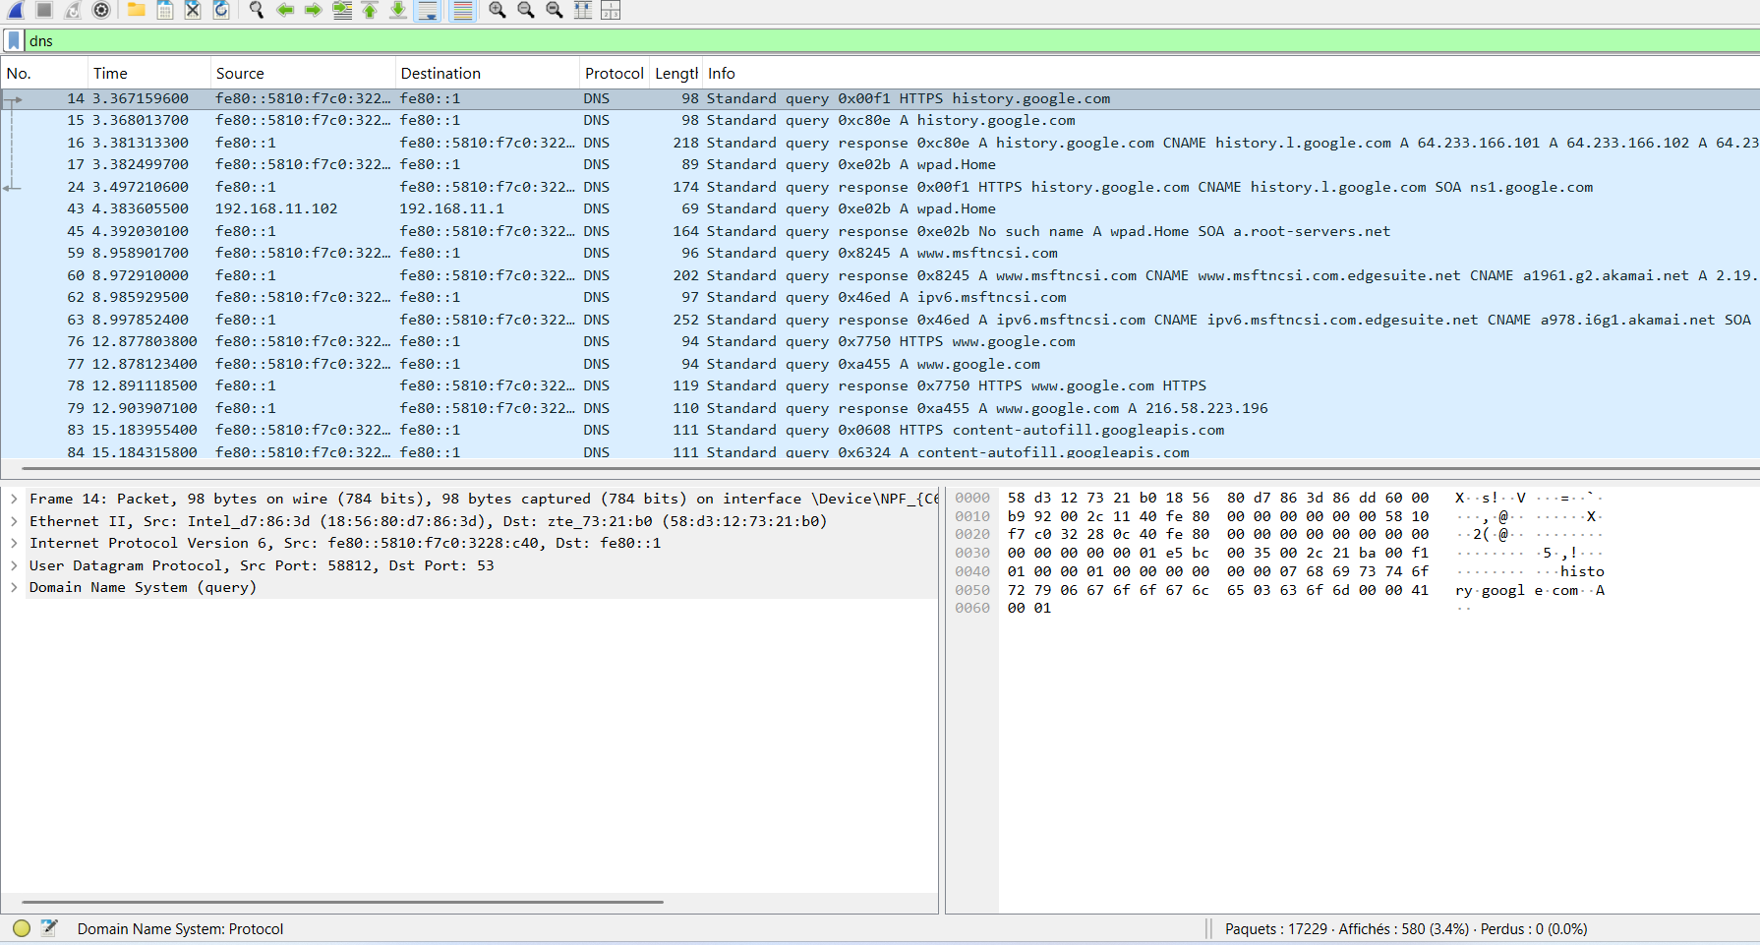

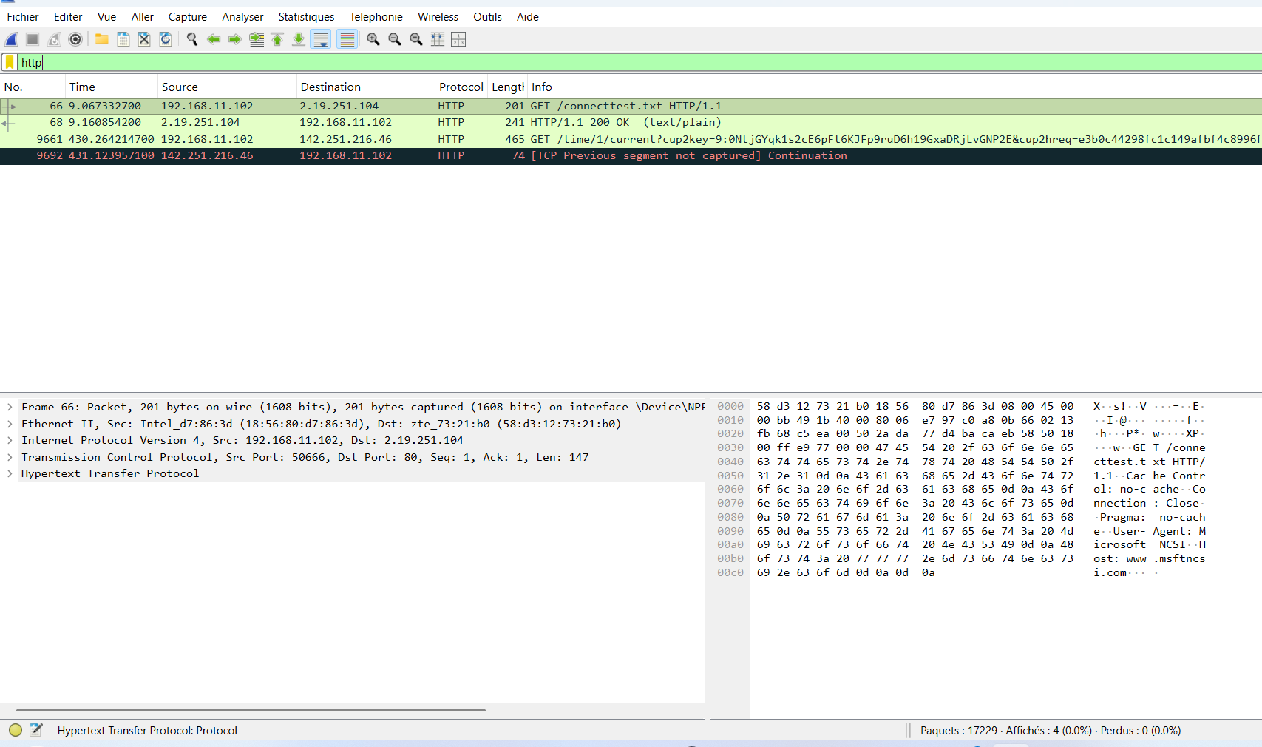

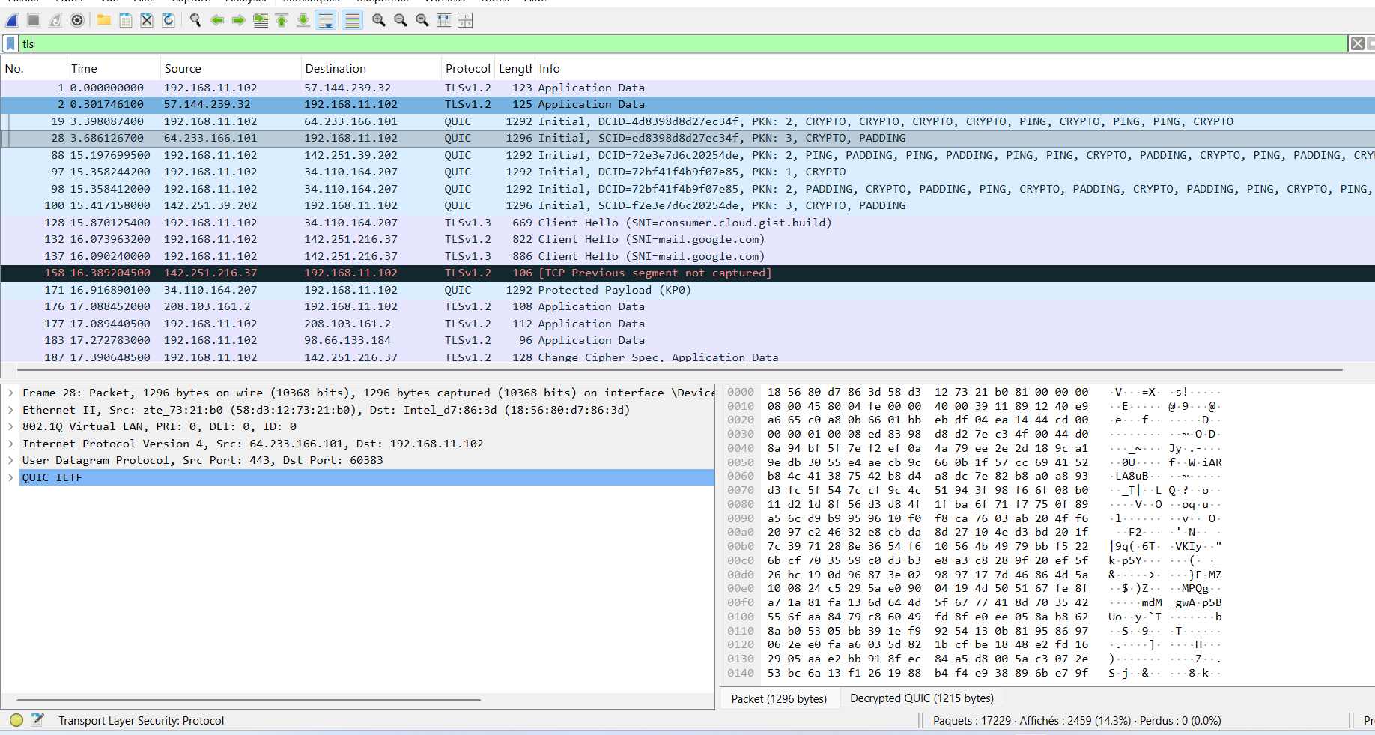
Results and Analysis

1. Approximately how many packets were captured?
Around 17229 packets were captured during the experiment. This shows a significant amount of network activity across different protocols.
2.List three protocols observed during the experiment.
- DNS → used for resolving domain names (e.g., queries for google.com).
- HTTP → unencrypted web traffic, visible in clear text (e.g., GET /connecttest.txt).
- TLS/HTTPS → encrypted communication ensuring confidentiality (e.g., TLS handshake with Client Hello, Server Hello).
(Additionally, TCP was observed as the transport layer establishing reliable connections, and QUIC appeared in the TLS/UDP capture.)
3.Why is encryption important when browsing the internet?
- Encryption ensures that sensitive information (passwords, personal data, browsing activity) cannot be read by attackers.
- It protects confidentiality and integrity, preventing interception or modification of data.
- Without encryption, traffic is exposed in clear text, making users vulnerable to surveillance and attacks.
4.What type of information could attackers obtain from unencrypted traffic?
- Visited websites and URLs (from DNS and HTTP requests).
- Login credentials or personal data if sent via HTTP.
- Files or messages transmitted without protection.
- Essentially, attackers can reconstruct a user’s browsing activity and intercept sensitive information.

